Name: ________________________ Date: __________
Anglo-Saxon Webquest

The purpose of this webquest is to explore the daily life, religion, and culture of the Anglo-Saxons. Learning about these aspects of Anglo-Saxon life will enhance your understanding of the time period and the Anglo-Saxon literature we will study.

__________________________________________________________________________________________
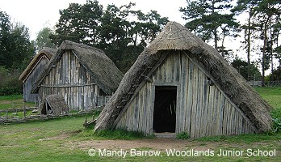
Homes and Halls

Go to the following website:
http://primaryhomeworkhelp.co.uk/saxons/houses.htm

- What happened to many of the towns set up by the Romans?

- What materials were homes constructed from?

- Describe how the houses were set up.

- Who lived in the Hall (mead hall)?

- Describe the set-up and atmosphere of a mead hall.

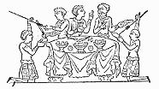

Food and Drink

Go to: http://primaryhomeworkhelp.co.uk/saxons/food.htm

- What types of food did Anglo-Saxons grow?

- What did they drink instead of water? Why?

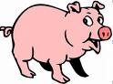
- Why were many Anglo-Saxons vegetarians?

- What was the only type of animal used just for its meat?

Go to: http://www.marga.org/food/int/anglosaxon/

- Scroll to the bottom and click on the three recipes. Of these three, which would you most prefer to eat? Why?

- What are three ingredients in the recipe above?
A.
B.
C.

Social Structure

Go to: http://www.britainexpress.com/History/anglo-saxon_life.htm

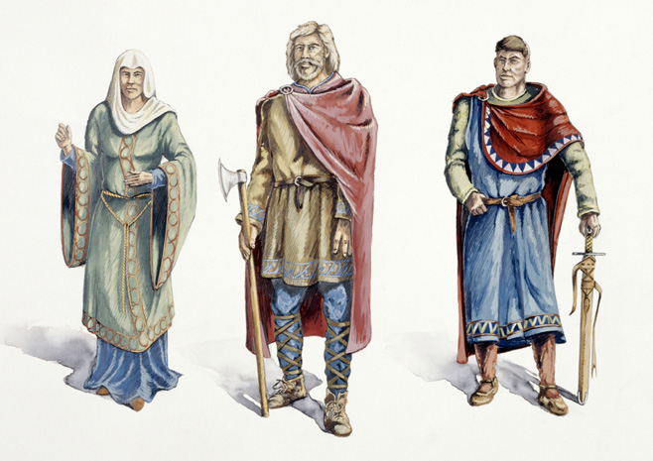
Scroll down to “A Lord’s Life.”

- Who was at the top of the social ladder?

- What was this person expected to provide?

- What were the two social classes below the king?

- What are three ways people became slaves?
A.
B.
C.

Go to http://octavia.net/slavery-in-anglo-saxon-england/

- What was the penalty for killing a slave?

- What was the penalty for raping a slave?

- What was the penalty for one slave raping another?

- Scroll to the last sentence of this page. Where were “freeing ceremonies” performed? Why?
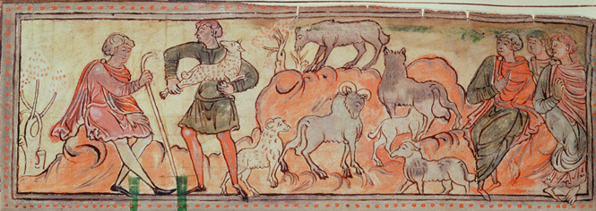

Daily Life

Go to: http://www.wikitree.com/articles/year-1000/

- If you were to go back in time to the year 1000 and meet an Anglo-Saxon, what is the first thing you would notice?

- What happened to people after the year 1000 and before today that made them smaller?

- At what age was a boy considered old enough to swear an oath to the king?

- When did most girls marry?

- When did most adults die?

- What disease found in skeletal remains that tells us these people worked hard?

Go to http://www.hullwebs.co.uk/content/c-anglo-saxon/home-life/anglo-saxon-women.htm

- What was morgengifu, and when was it given?

- If a woman wished to divorce her husband, how much money and property was she entitled to?

Medicine

Go to http://octavia.net/herbal-healing-and-charms/
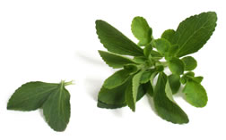
- What is the Anglo-Saxon title of this page?

- What does it mean?

- What items were used in healing both the body and spirit?

- What did people do to wounds to speed healing?

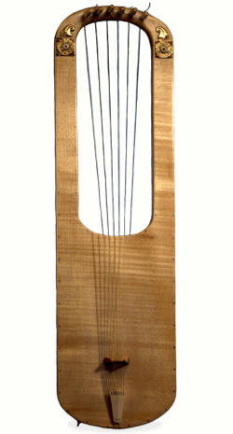
- What is the title of one of the Charms listed?

Games and Entertainment

Go to http://www.bbc.co.uk/schools/primaryhistory/anglo_saxons/stories_and_pastimes/

- What story is mentioned under “story-telling?”

- Click on “Riddles and Runes” in the left column. What do you think the answer to the riddle is?

- Click on “Games and Sports.” What are some sports they enjoyed?

- What were the gambling dice found in the grave made from?

Go to http://anglosaxondiscovery.ashmolean.org/Life/dailylife/games_info.html

- What are two board games listed on this page?

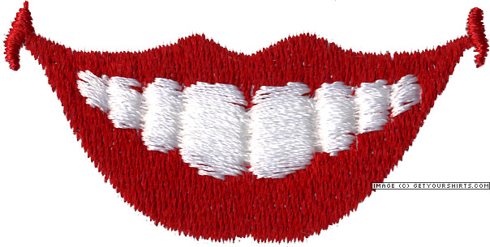
Lookin’ Good

Go to: http://octavia.net/early-cosmetics/

- What are two things Anglo-Saxons used to brush and polish their teeth?

- What did the Swedish anthropologist find in the teeth of 24 Viking-era men?

- What were some possible purposes for this?

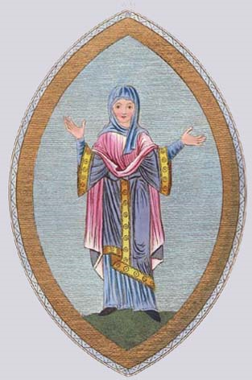
- How does this penalty tell us about long hair on men?

- What did people use for eye makeup?

- What are 3 reasons people throughout the ages have had tattoos?

- How were tattoos accomplished?

Go to: http://octavia.net/medieval-clothing/

- What material was used for most clothing?

- Did women wear underwear other than a slip (shift)?

- What did they wear over their shift?

- What were some colors of clothing?

- What did men wear?

Religion

Go to http://www.hullwebs.co.uk/content/c-anglo-saxon/religion/religion.htm
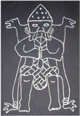
- What are some aspects of life that the Anglo-Saxon pagan (heathen) gods ruled?

Go to http://gwydir.demon.co.uk/jo/nordic/index.htm

- Click on one of the gods listed in the left column. Write a sentence about that god:

- Go back to the previous page. Click on one of the stories from the right column. What is the story about?

- Go to http://gwydir.demon.co.uk/jo/roman/daysweek.htm

We get the names of the days of the week from Saxon gods. Fill in the blanks below:

Monday= _____________’ s day (god of _____________________________)
Tuesday= _____________’ s day (god of _____________________________)
Wednesday=_____________’ s day (god of _____________________________)
Thursday=_____________’ s day (god of _____________________________)
Friday=_____________’ s day (goddess of _____________________________)
Sunday=_____________’ s day (god of _____________________________)

Go to: http://primaryhomeworkhelp.co.uk/saxons/religion.htm
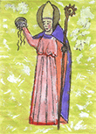
Scroll down to “From Pagan to Christianity”

- About how long ago were the pagans converted?

- What is the name of the man who converted the king in Kent?

- Where did this man build a church?

Go to http://gwydir.demon.co.uk/jo/nordic/runes.htm

- What are runes?

Go to http://gwydir.demon.co.uk/jo/nordic/runes3.htm

- Write your first name in the box. Copy down the runes (symbols shown) below:

Go to: Beowulf Vocabulary handout
61-68. Read the Beowulf Vocabulary handout and the definitions. Go some searching on Google to find the definition for the blanks found on that worksheet.

Go to https://www.youtube.com/watch?v=7Wl-OZ3breE
69. Listen to the Lord’s Prayer in Old English. What other language does it sound most like? Are there words you recognize?

Go to http://www.collierhighschool.com/common/pages/DisplayFile.aspx?itemId=13678560 and click the document that pops up. It may help you find answers to the questions above as well as those below.
70. From what land did Beowulf hail?

71. What land did he go to in order to help?

72. What are the four differences between Anglo-Saxon’s previous beliefs and actions and that promoted by Christianity?

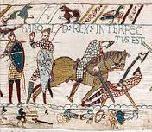
Go to: http://www.bbc.com/news/uk-england-28018096
73. What story does the Bayeux Tapestry tell?

Go to: http://www.behindthename.com/name/beowulf
74. What did the name Beowulf mean?

Bonus Points: Look up your own name. What does it mean? http://meaning-of-names.com/

Go to: the textbook and answer the questions below:
- Explain the highlights from the timeline below:
  - 55BC—AD 409

  - AD 449

  - AD 400-699

  - AD 1066

- Describe Celtic animism.

- Where does the word “Druid” come from and what Christmas celebration was derived from them?

- What is the difference between Celtic legends and Anglo-Saxon ones?

- From where did the name England derive?

- What king unified England and what aided him in connecting everyone?
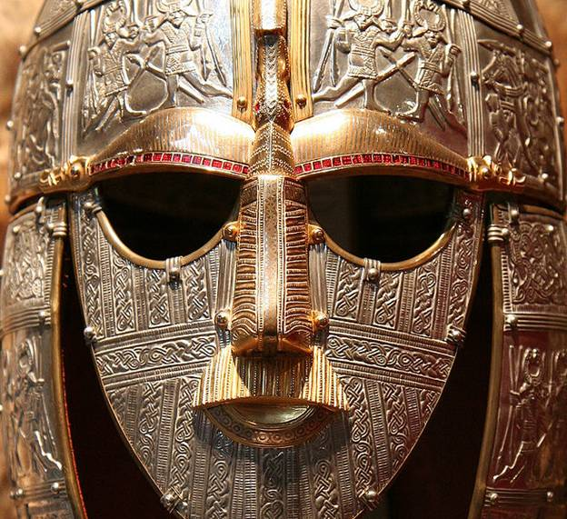

- Who/what is Sutton Hoo and what’s it reveal?

- Explain why loyalty was important to the Anglo-Saxons.

- What did dragons represent for the Anglo-Saxons?

- Why were bards/scops so revered?

- How did the Battle of Hastings and William the Conqueror coming with the Normans change England?
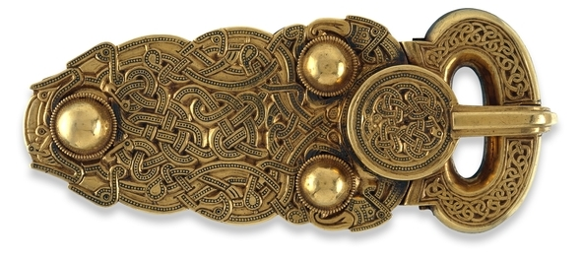

- Explain the importance of interdependence.

- What are the most common themes in Anglo-Saxon literature?

